**Assignment 4: Angular**

**Name: Ida Bagus Ketut Yoghantara**

Project Scenario

You have been approached by a Car Dealership company XYZ Cars. As part of their new initiative, you are asked to set up a basic Angular application to which Angular components will be added. You are supposed to setup an Angular environment.

1. **Setup NodeJS**

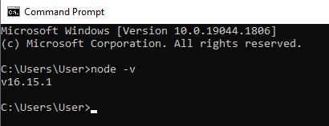

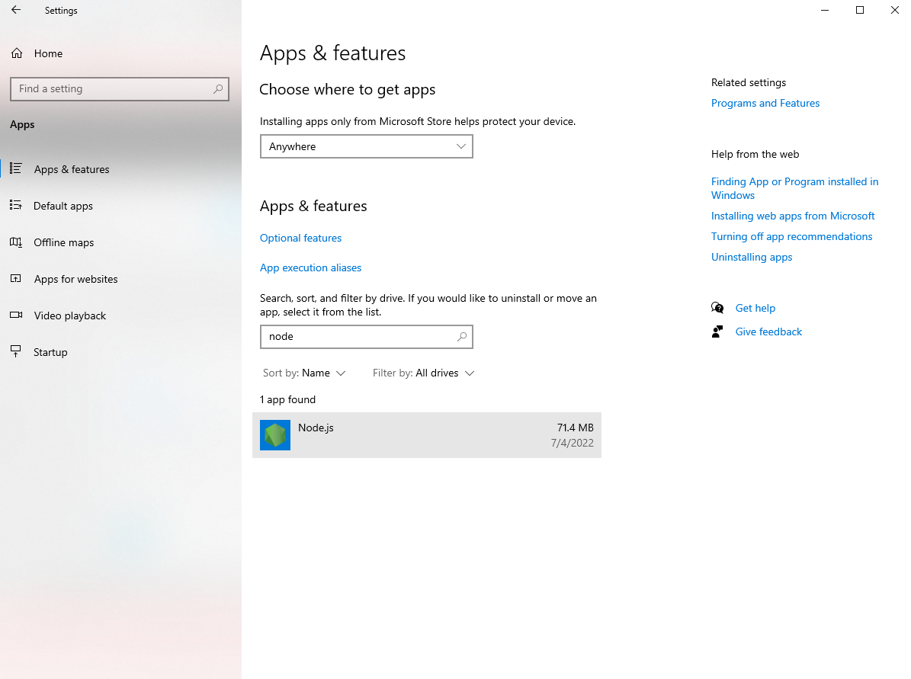

1. **Setup an Angular Project using Angular CLI**

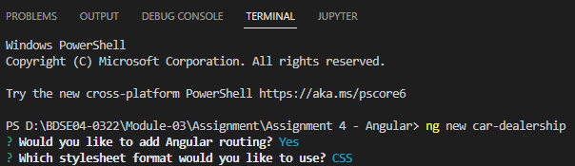



1. **Run the Angular Project using ng serve --open**

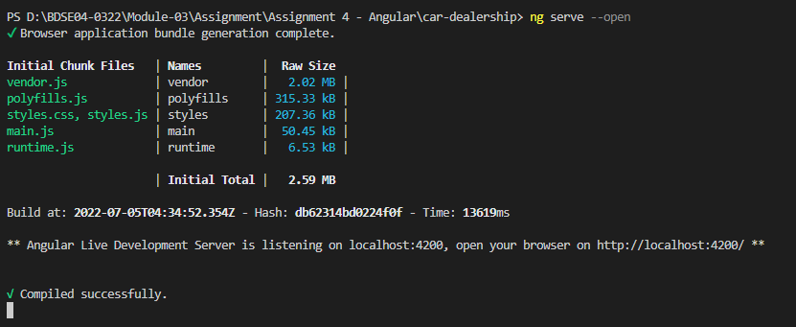

1. **Provide the script to generate an Angular Component using Angular CLI**

**ng generate component <component name>**

**ng g c <component name>**

1. **Generate an Angular Component called WelcomeComponent**

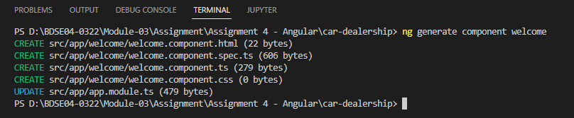

1. **Include the text “Welcome to XYZ Cars…” in the Component**

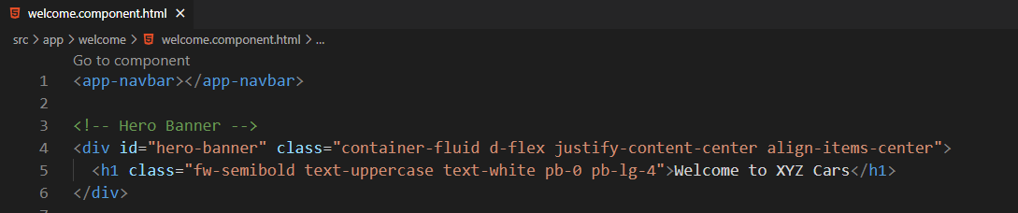

1. **Include the Component created as part of AppComponent**

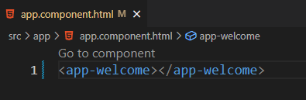

1. **Create 2 Components**
   1. **One for displaying Cars On Sale**

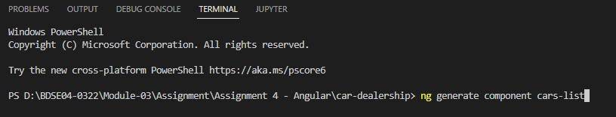

* 1. **Detail of a Car which is being clicked**

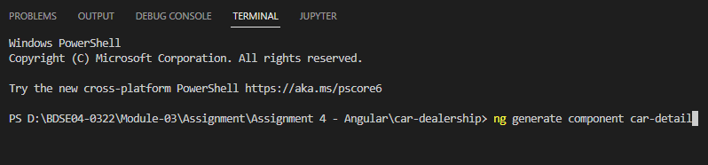

1. **Configure 2 Routes**

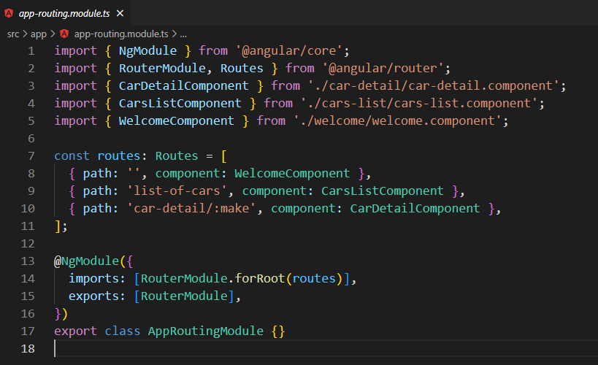

1. **Create a Custom Service to provide test Car Data with 3 fields, Make, Model, Year, Description & Car Photo & subscribe to the service**

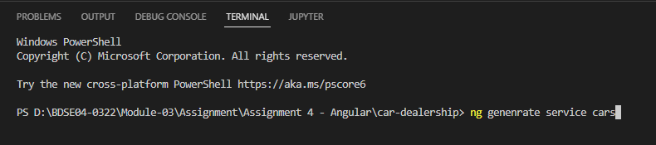

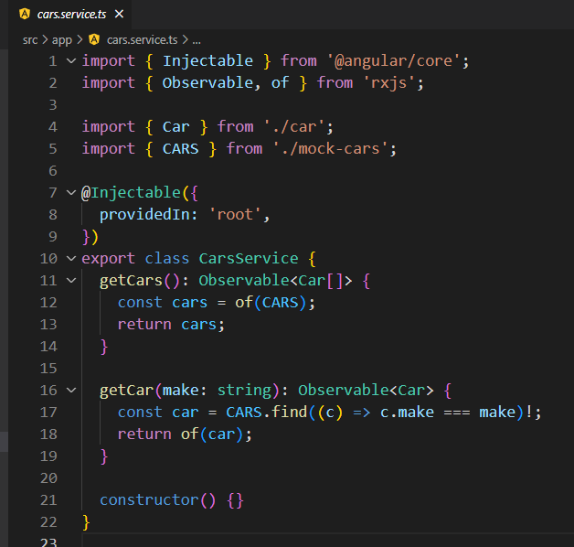

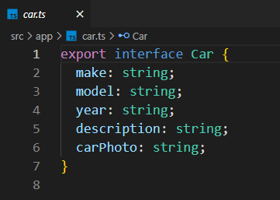

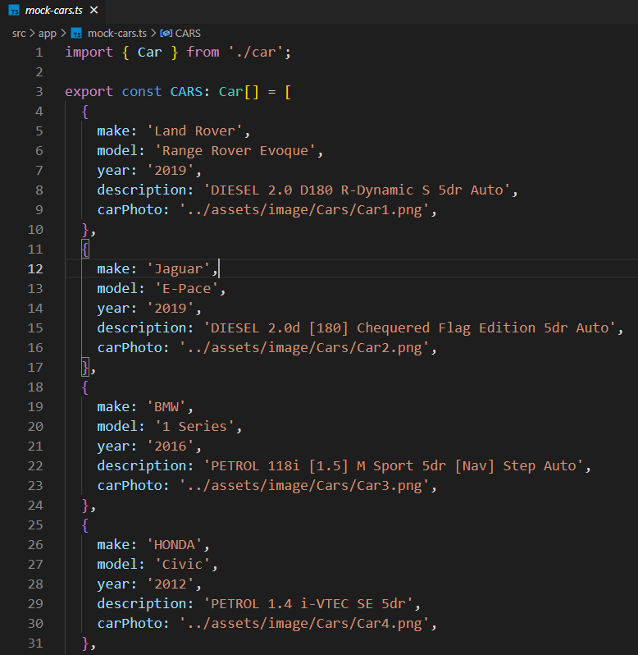

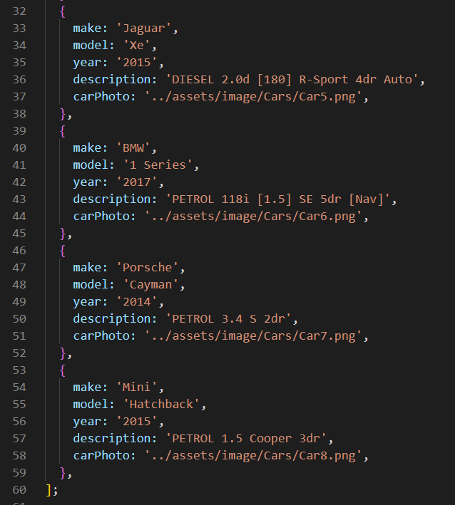

1. **Include the 2 Components in the AppComponent**

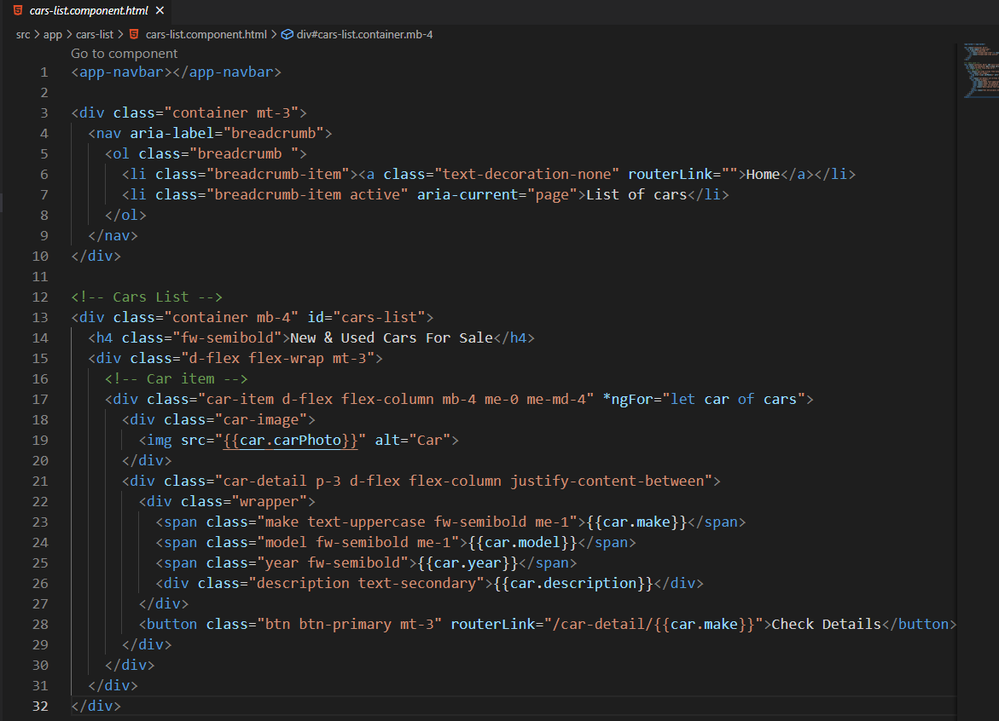

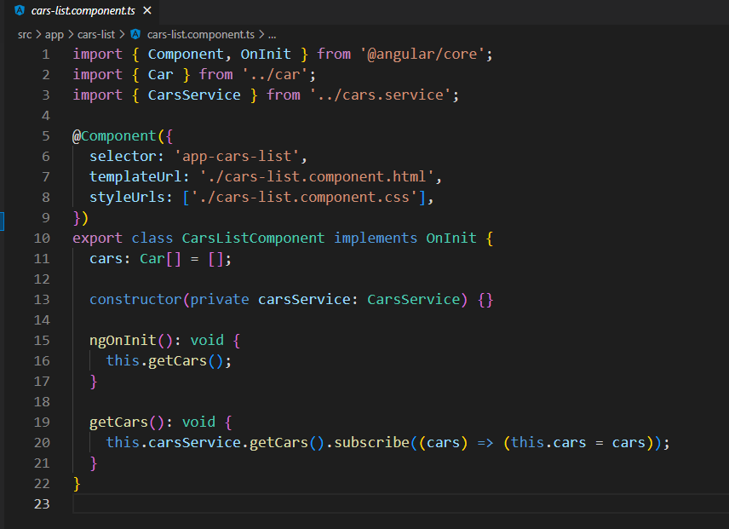

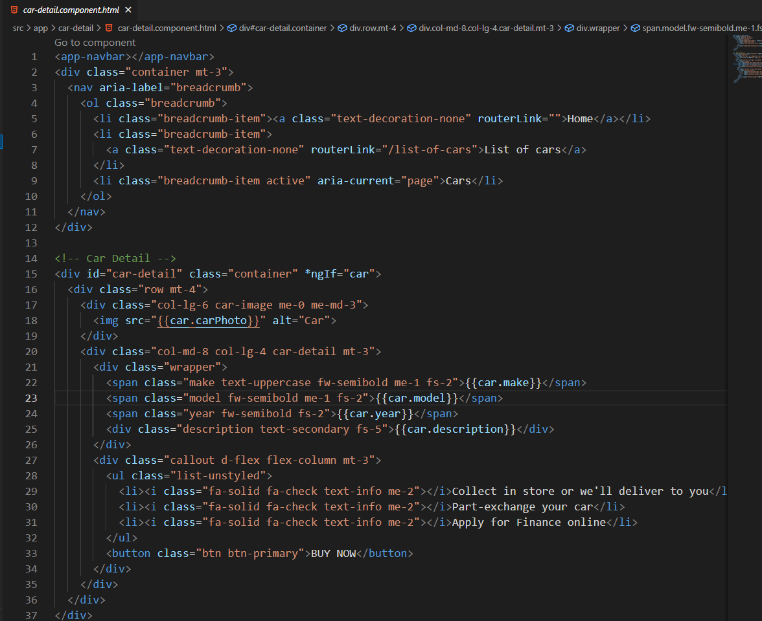

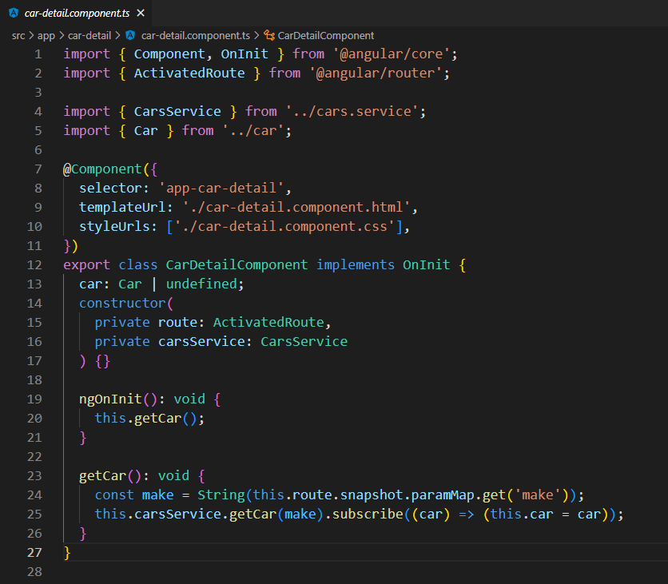

1. **The final project should have a Welcome Screen, List of Cars Screen and Car Detail Screen**

**Provide screen capture & Sources**

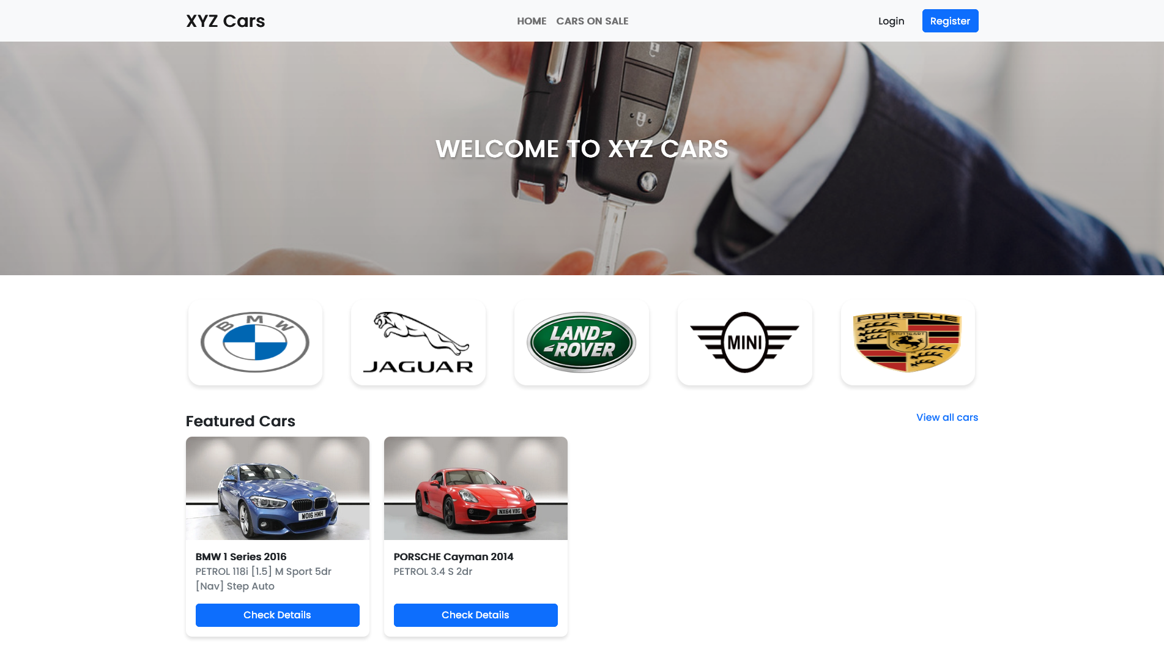

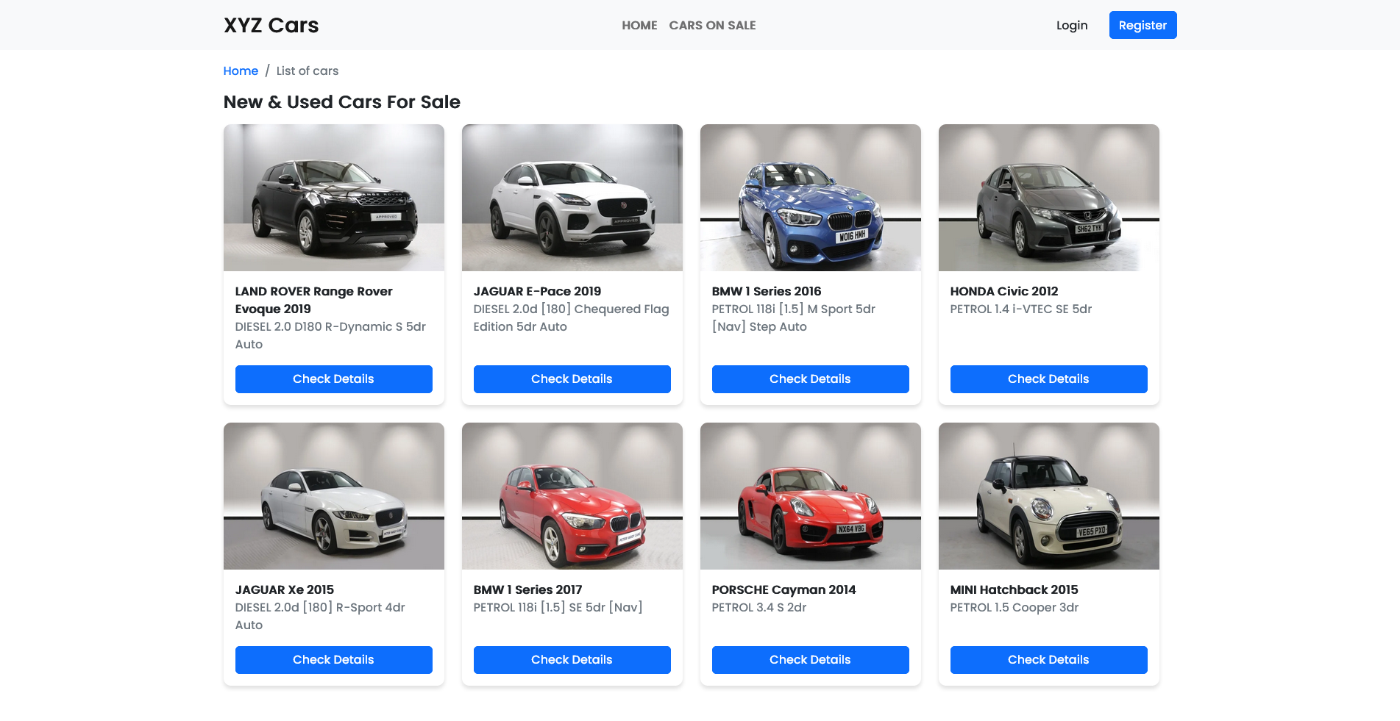

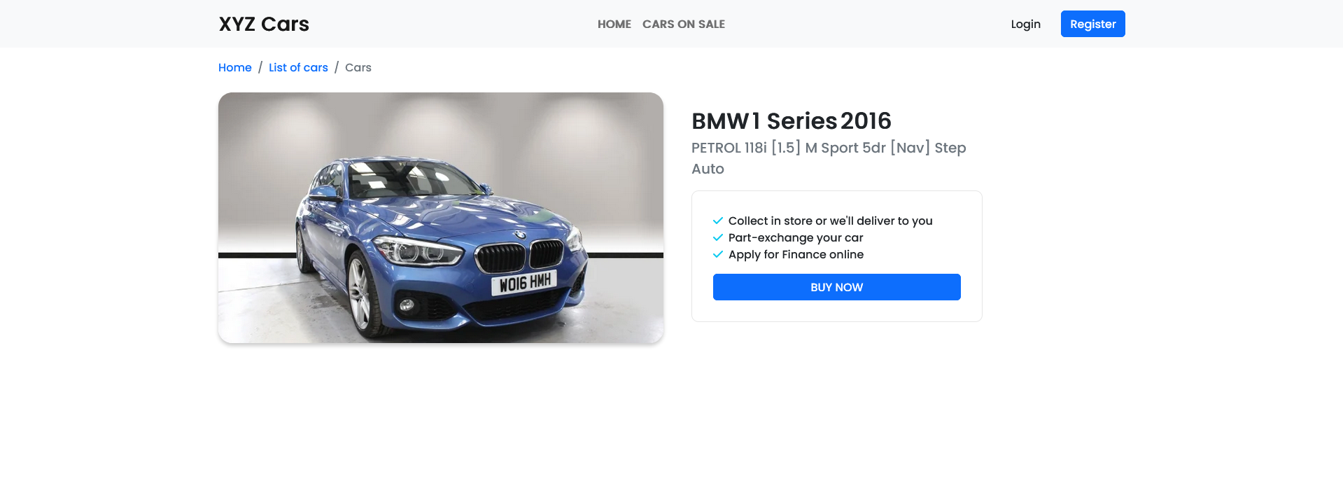

**Source Code**

